ADMIN (ORACLE) TESTING

1. If you want to view reports of all the traders then you need to click on View Report button on the top side of your Dashboard.

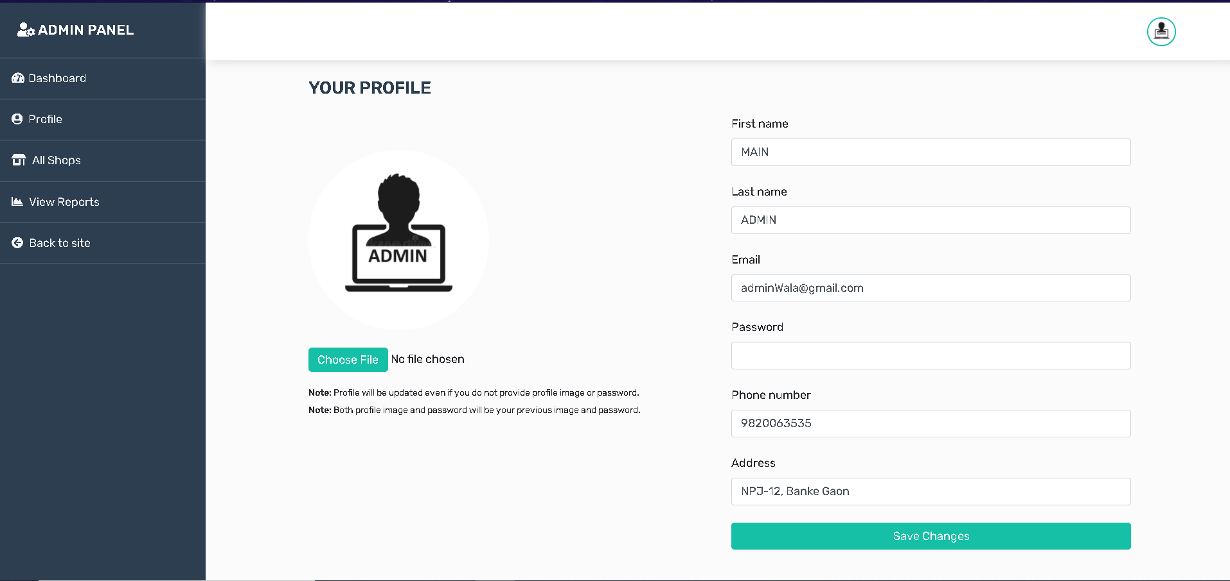

1. After clicking on it will redirect you to Oracle Dashboard from where you can login with your username and password

* Invalid login credentials.

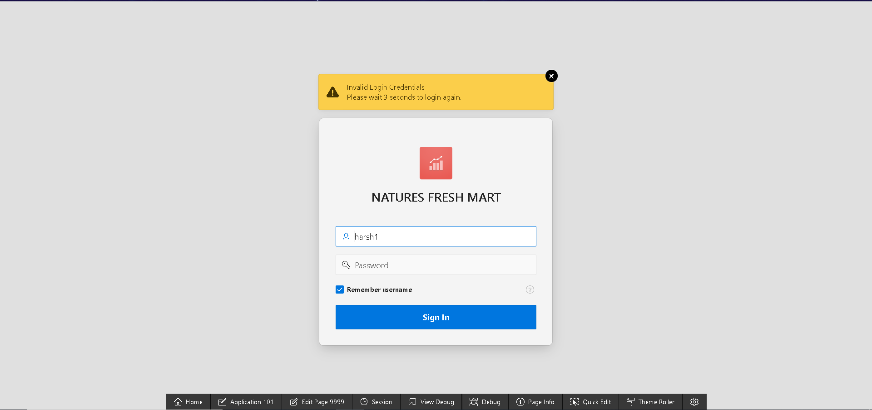

* Valid Login Credentials.(Directed to Oracle)

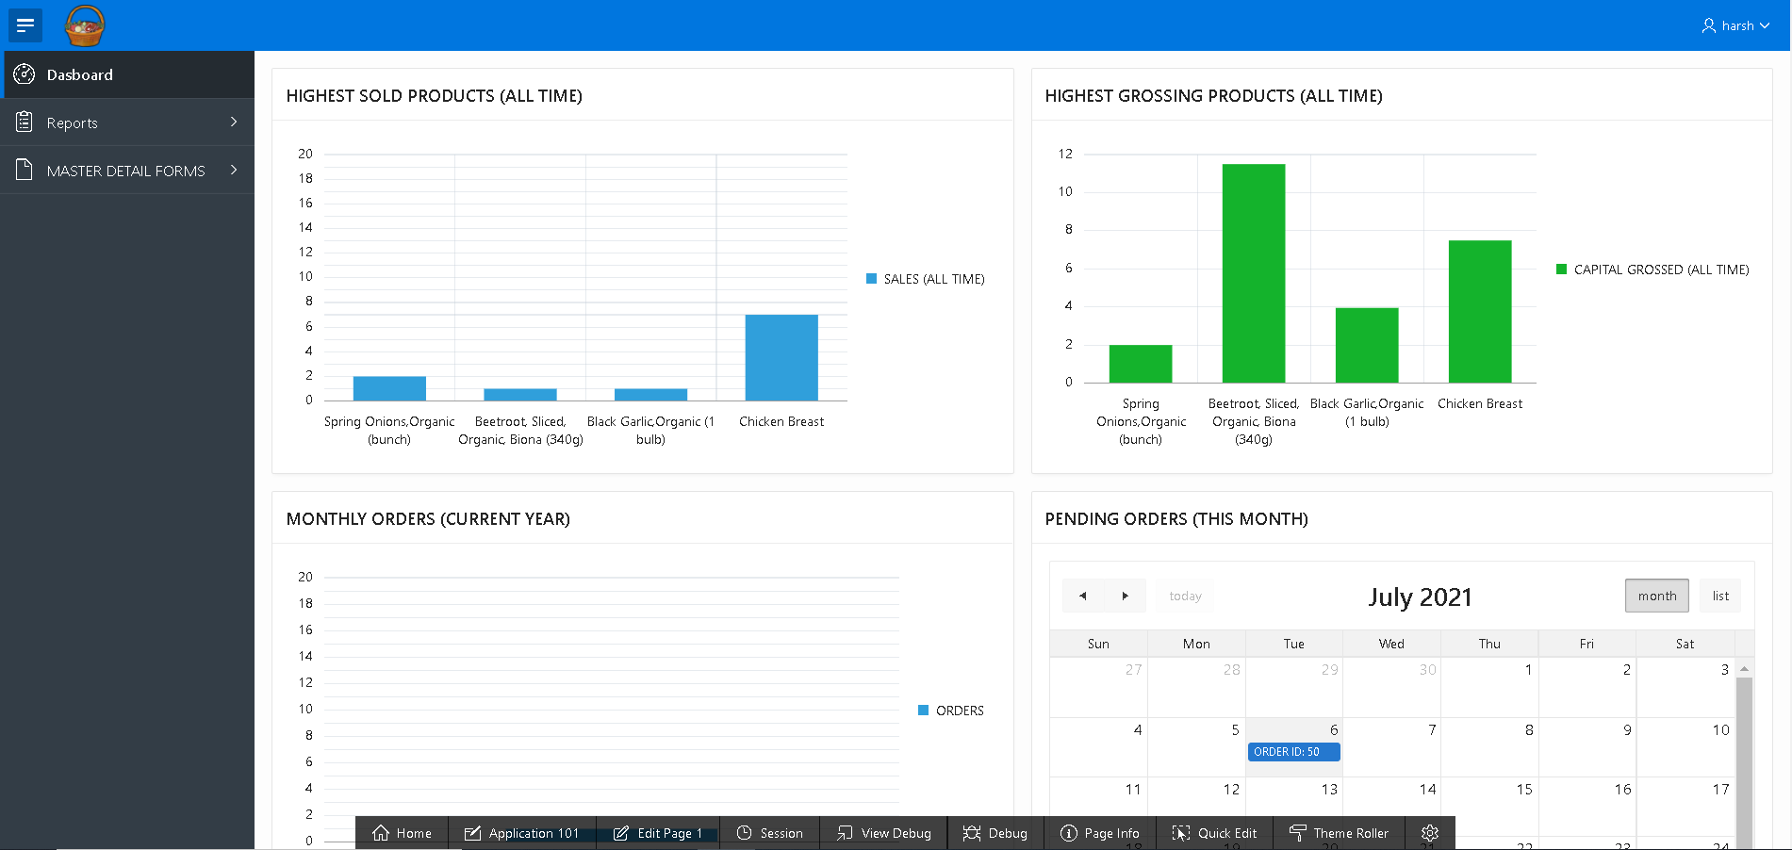

1. After login in with correct login details as Admin you’ll have access to the reports of all the traders, master-details of shop and products and product and reviews, information of highest sold products, and you can also view bunch of graphs, pending order in calendar

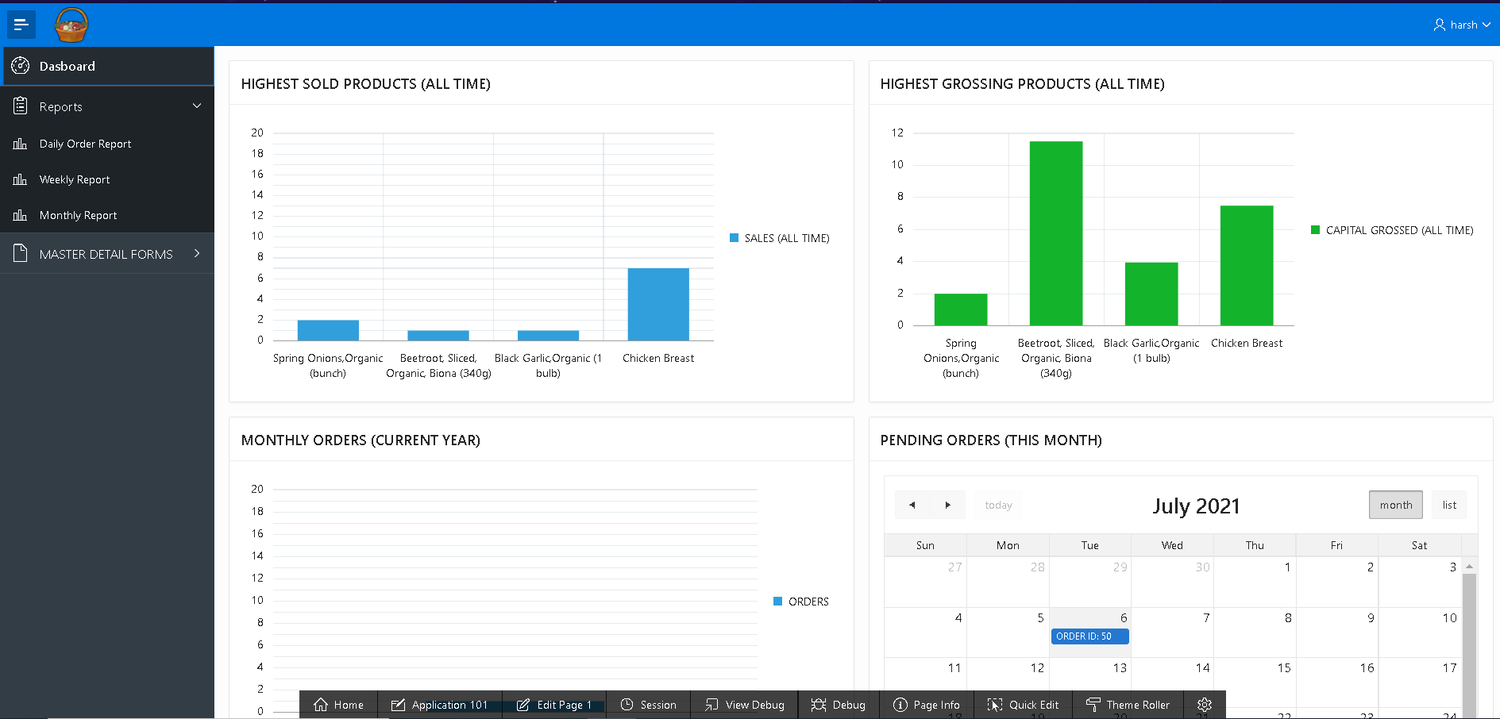

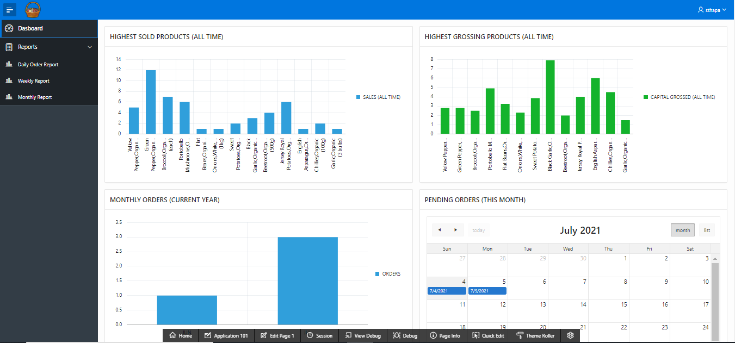

1. ADMIN DASHBOARD displays reviews of all products (all trader) in MASTER DETAIL FORM where product is master form and detail form is Reviews

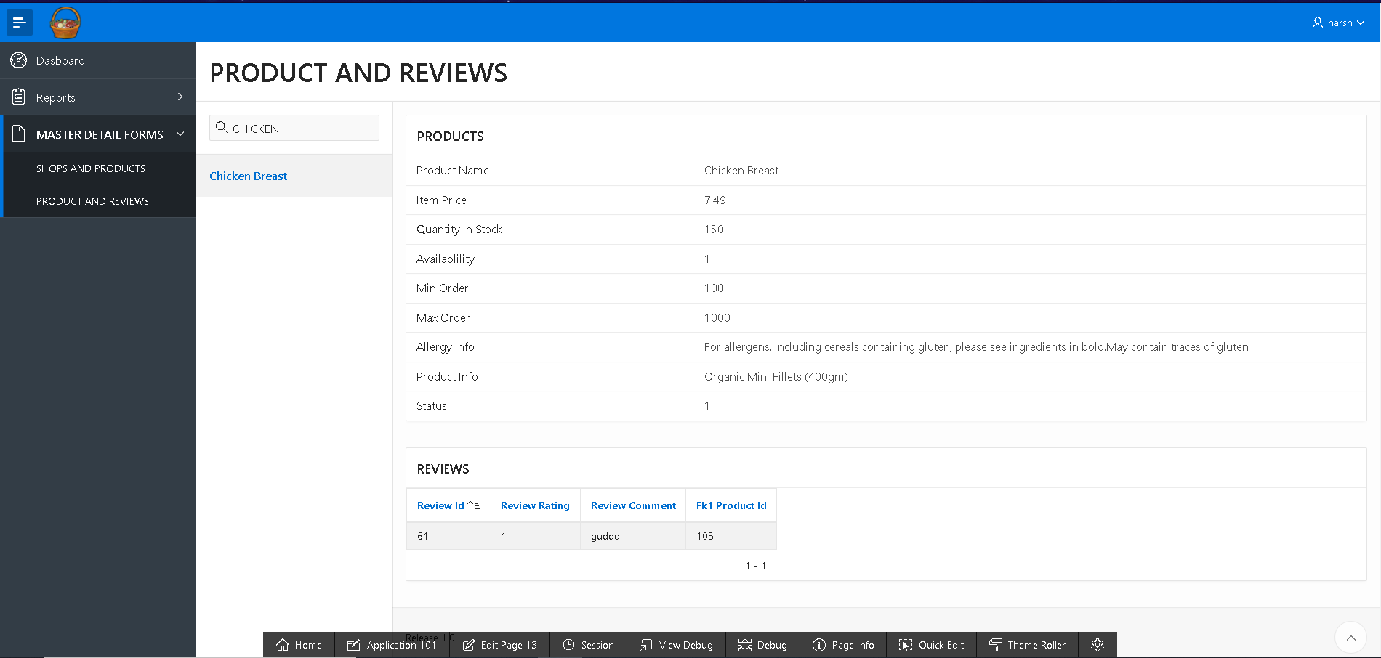

1. SHOPS AND PRODUCTS display all the shops and the products in master-detail form. The shop is the master form and product is the detail form.

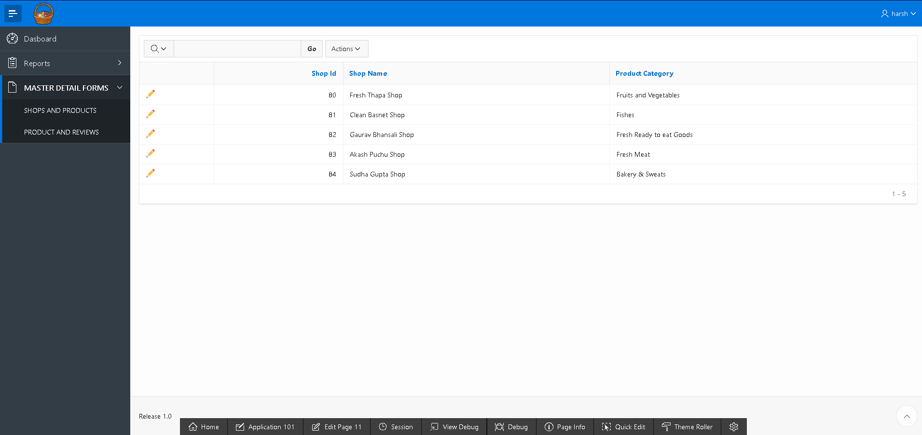

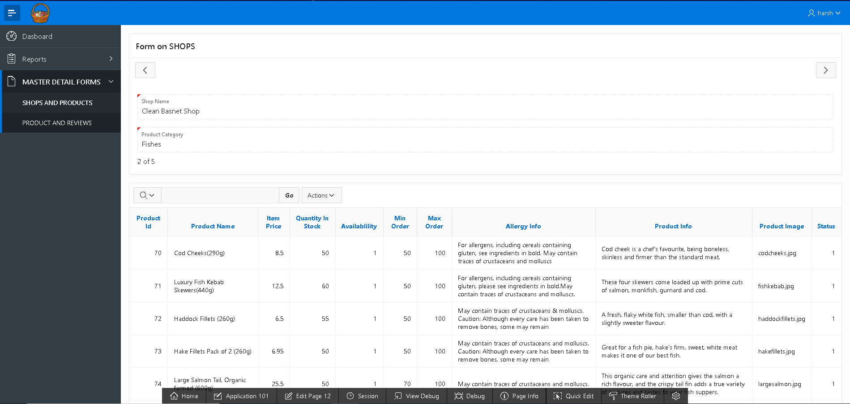

1. DAILY_ORDER REPORT will display yesterday’s orders made by the customers along with income.

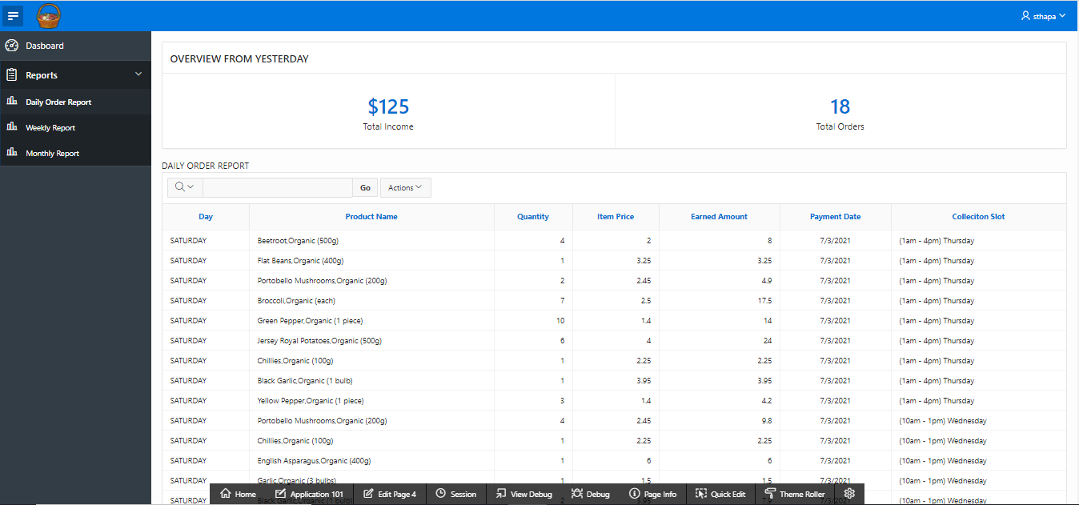

1. WEEKLY REPORT displays quantity, income of all the traders in past 7 days.

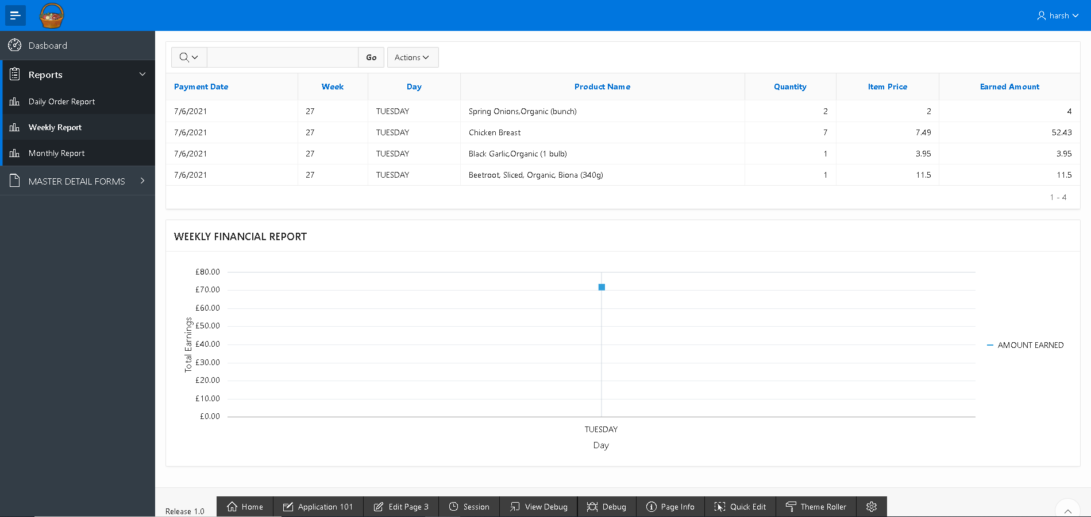

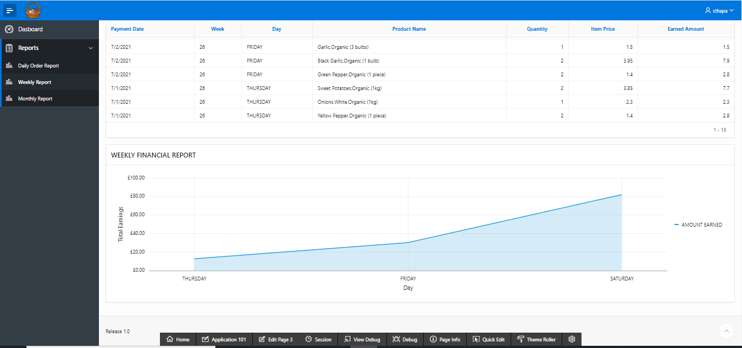

1. MONTHLY_REPORT displays quantity sold in past 30 days all the traders, earned amount and also a chart.

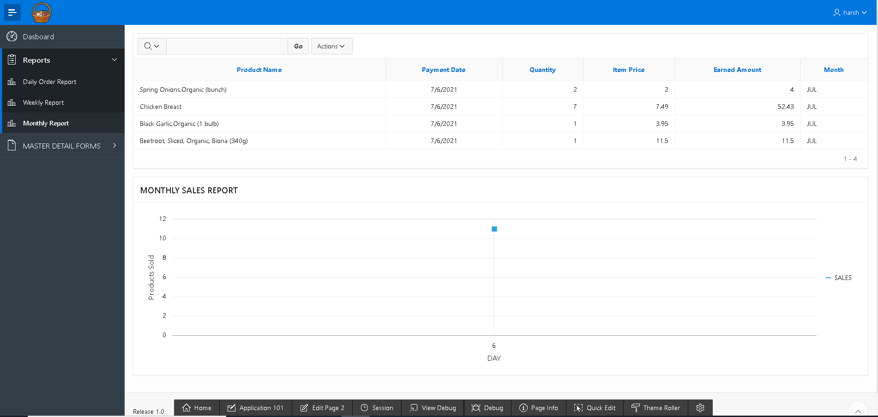

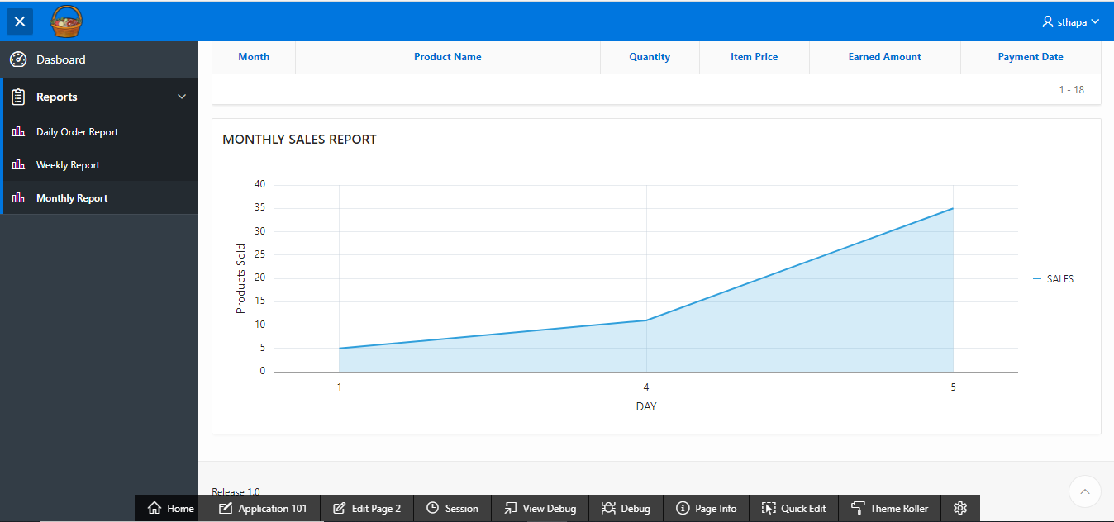

1. You can logout by clicking on username and then Sign out.

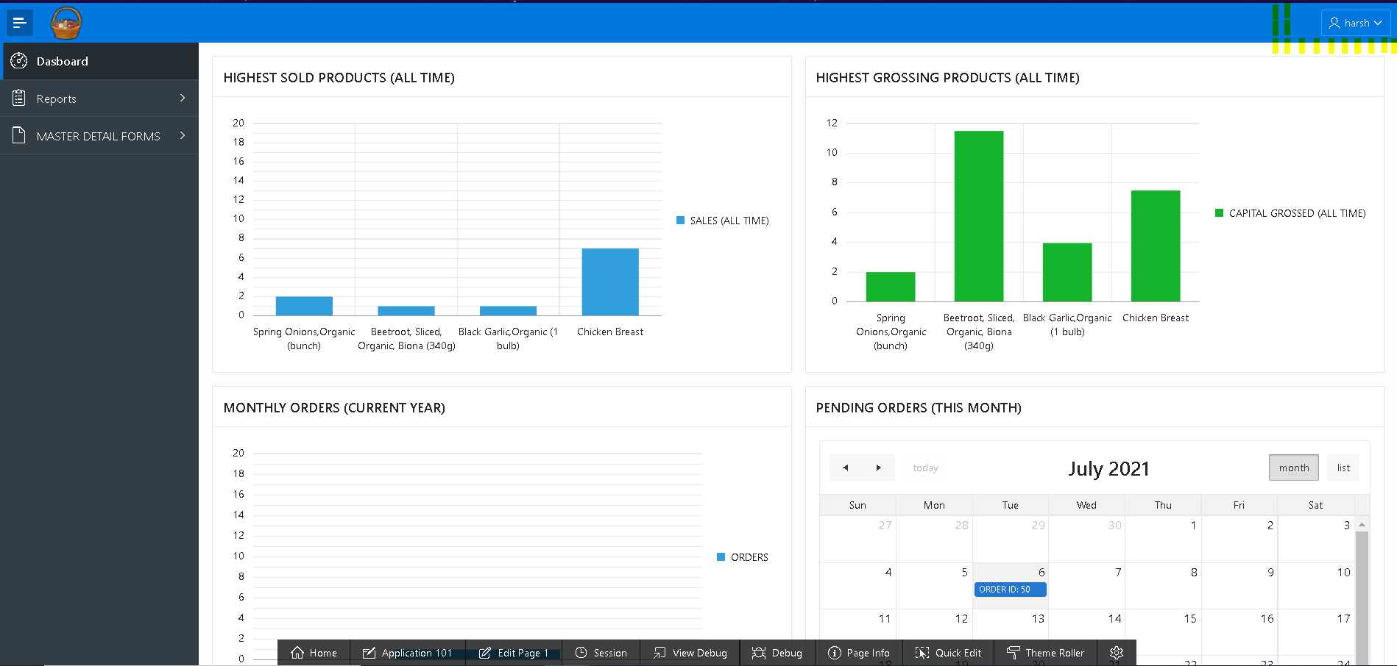

Logout